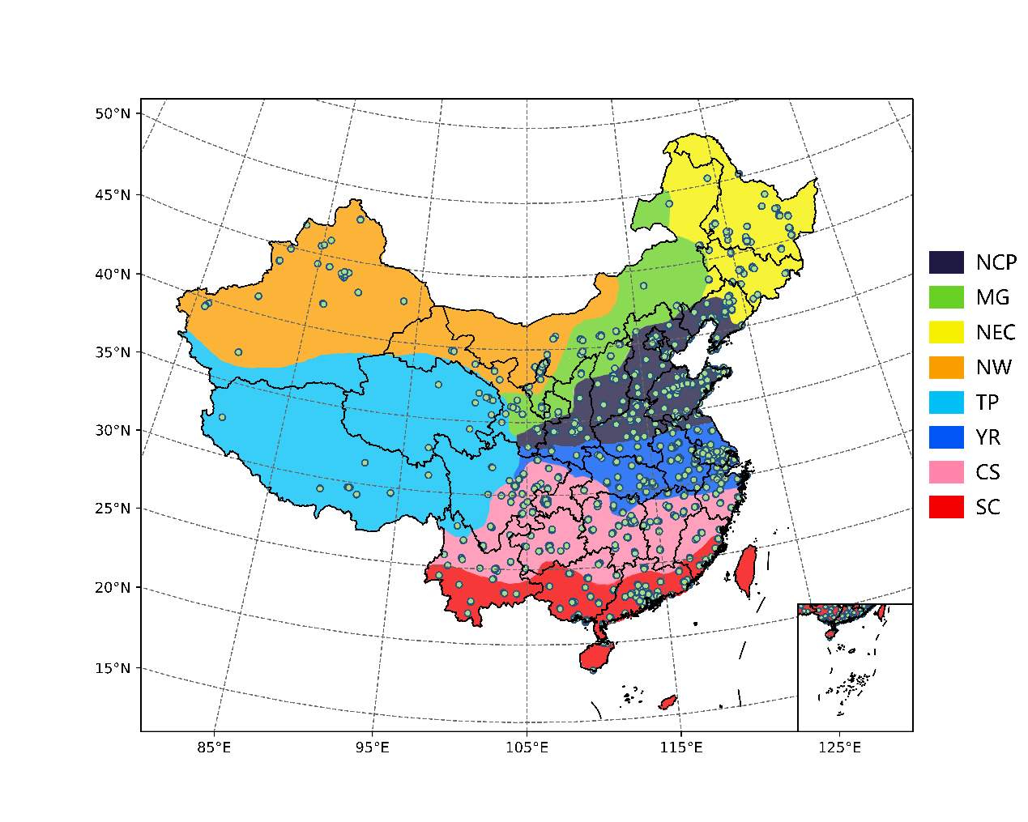

Fig. 1. Air pollution monitoring station distribution and climate zoning.

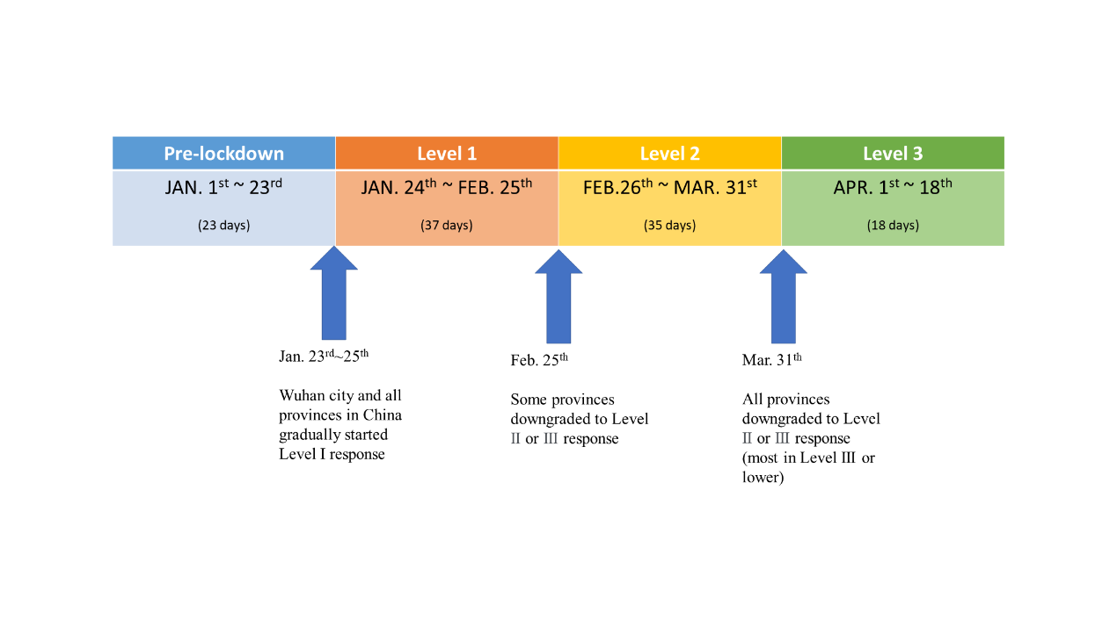

Fig. 2. Lockdown timeline during the study period.

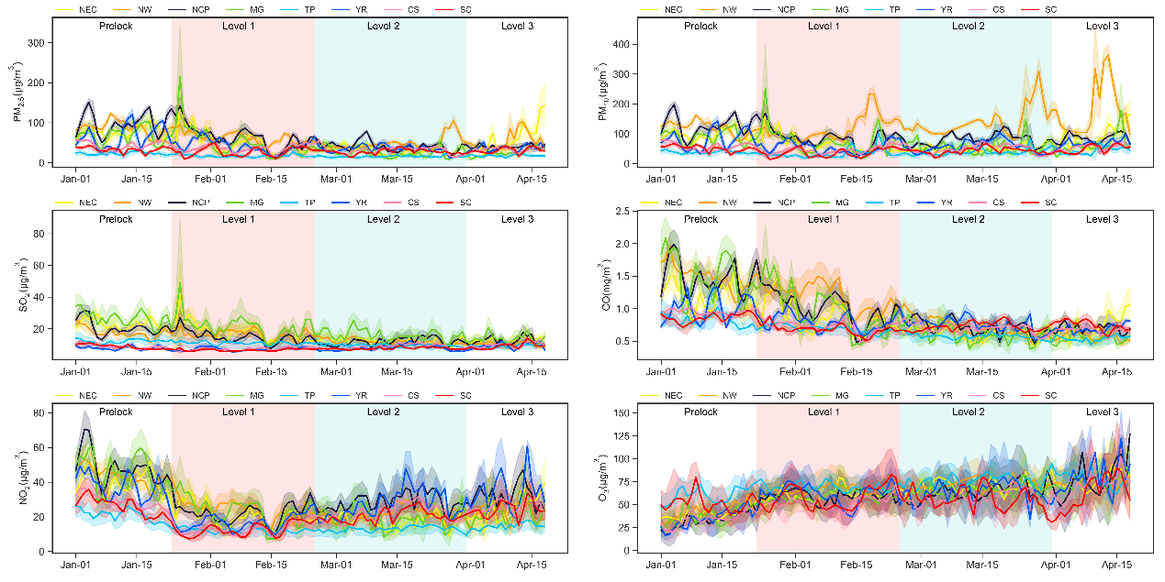

Fig. 3. Temporal series of the daily average of PM2.5, PM10, SO2, CO, NO2 and O3 from January 1st to April 18th

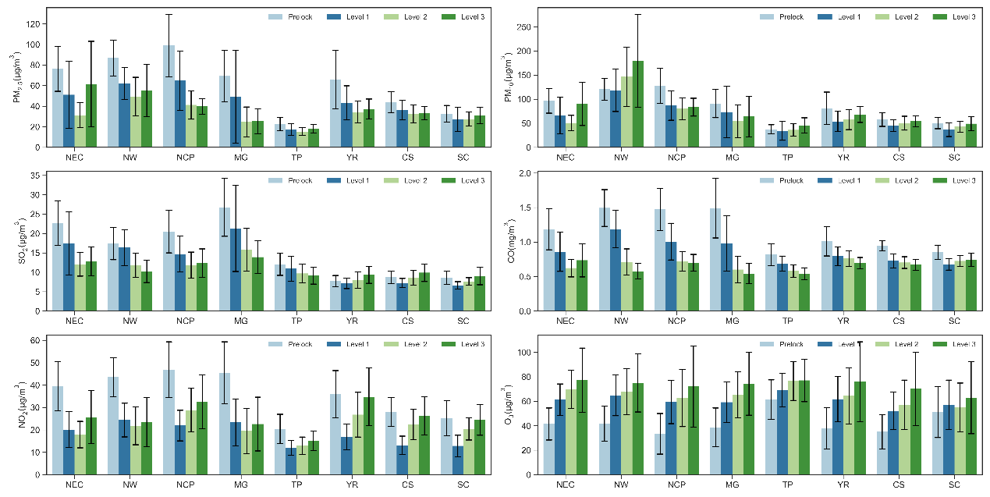

Fig. 4. The average concentrations of Pre-lockdown, Level 1, Level 2 and Level 3.

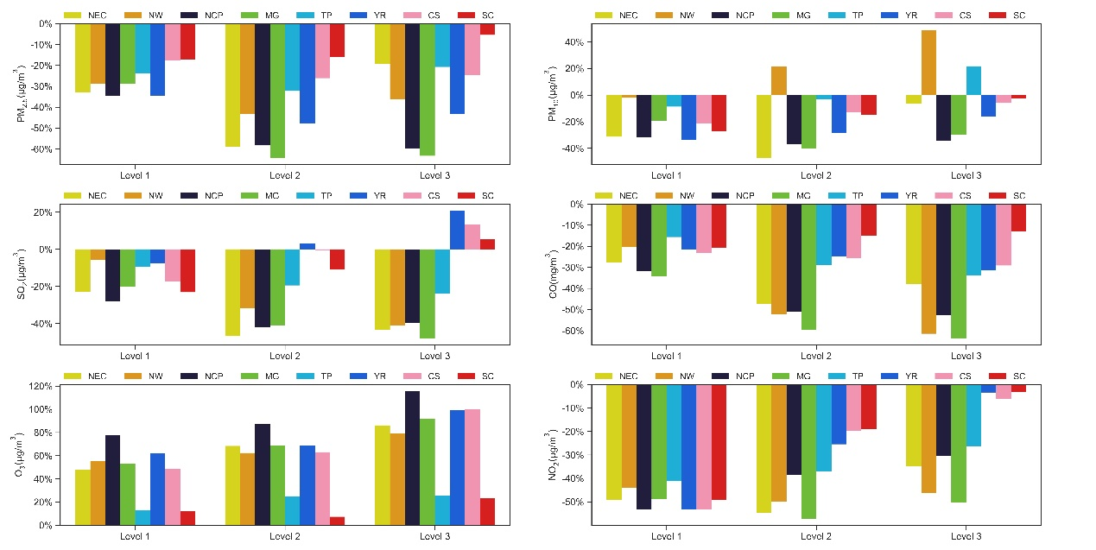

Fig. 5. The ratio variations of Level 1, 2, 3 compared to Pre-lockdown concentration 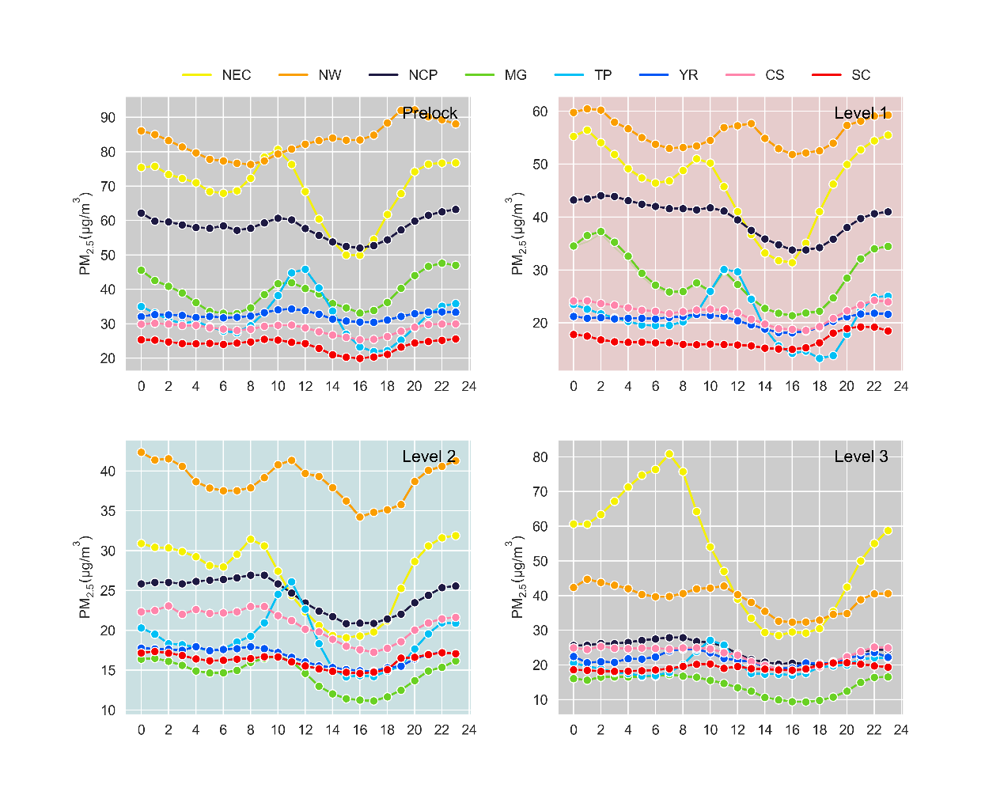

Fig. 6. PM2.5 diurnal variation of four stages.